**TASK 2**

* Design a Jenkins pipeline that should be triggered in case of any commit to the GitHub main/master branch and the execution should happen over the Slave agent. The pipeline should be responsible for installing the latest version of Chrome browser and chromedriver.
  + **Jenkins master:** Ubuntu 20.04 LTS
  + **Slave agent:** Ubuntu 20.04 LTS
* Create a Readme/Documentation to explain the working of the Jenkins Pipeline setup.

I had used AWS ec2 service for the jenkins server deployment.

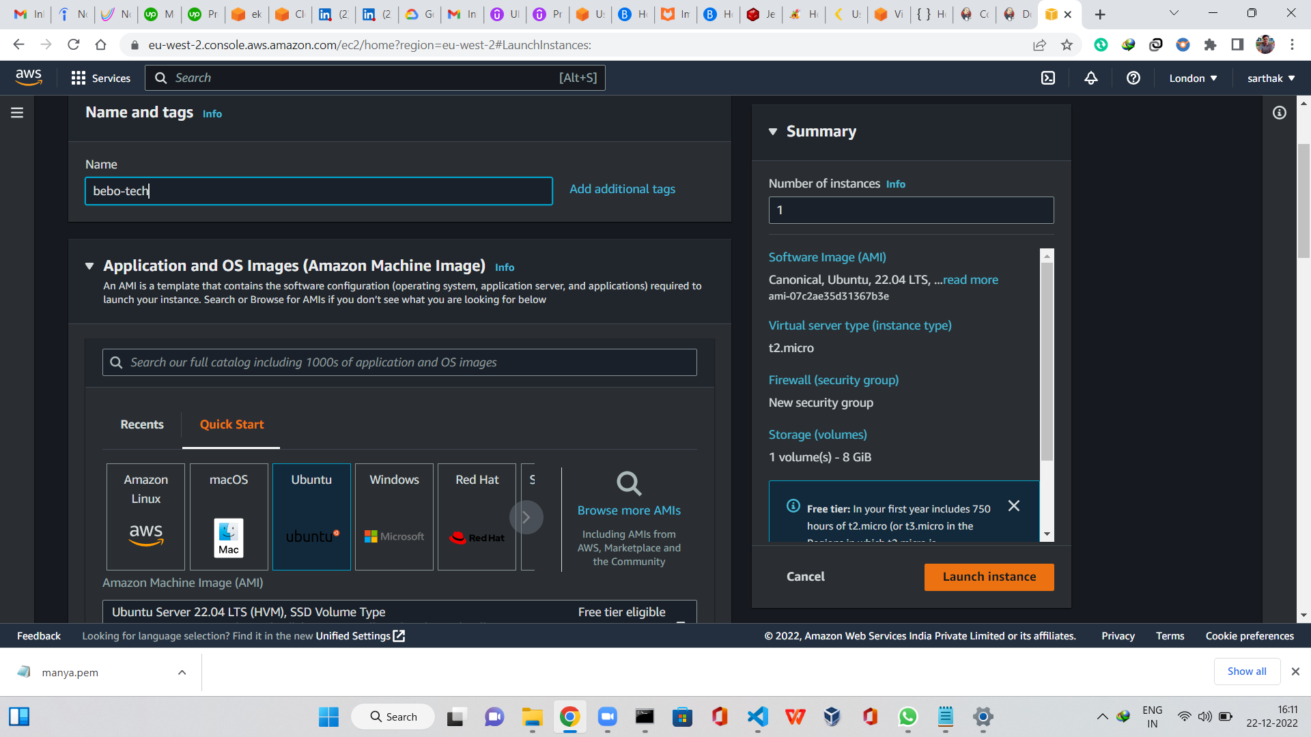

The configuration and start-up script is listed below, which has installed jenkins in the ubuntu 22.04 machine.

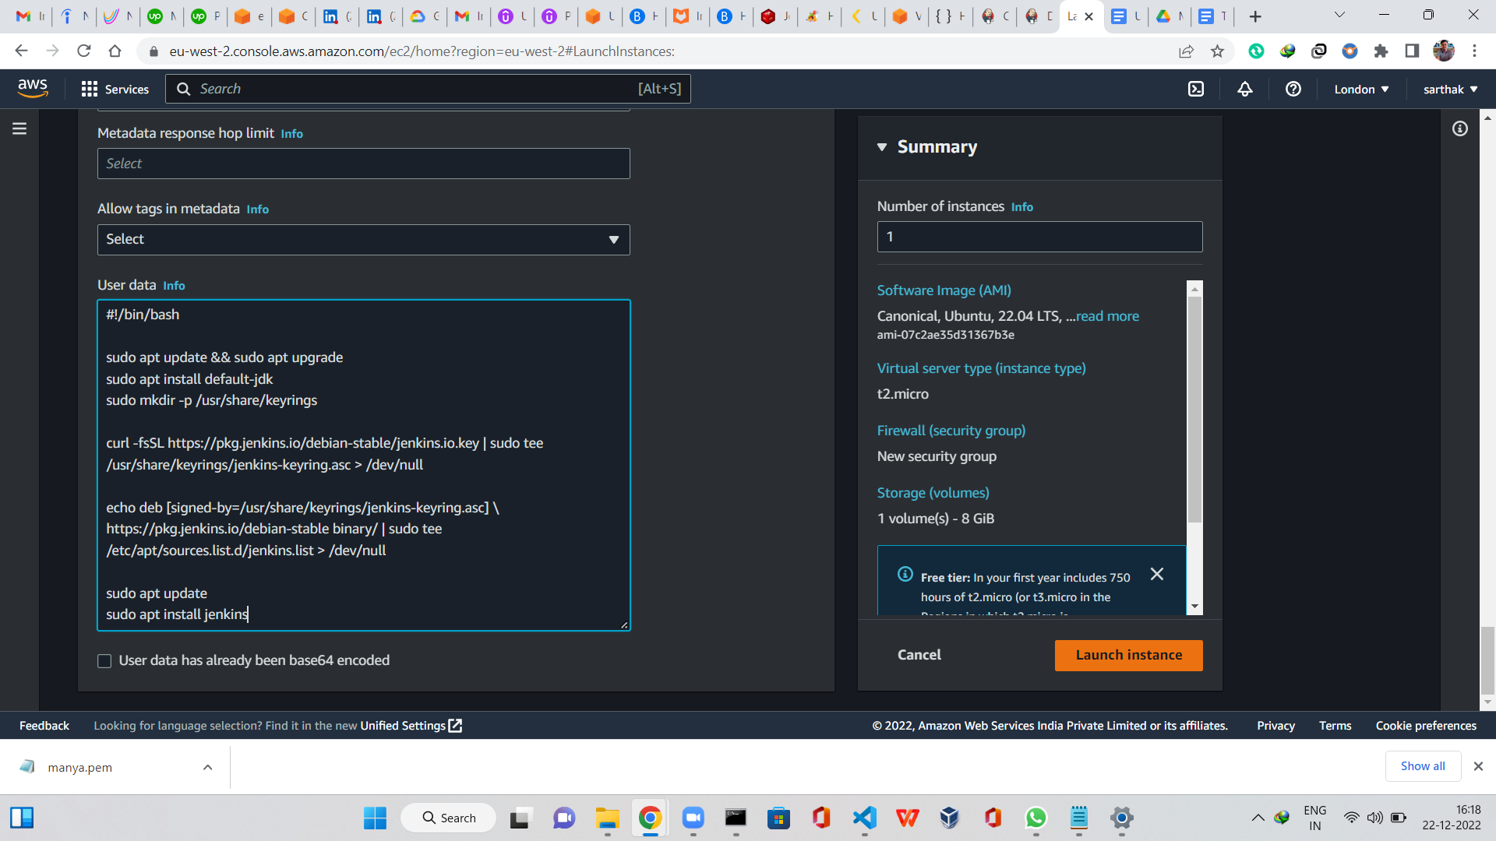

The jenkins status which is actively running after installation.

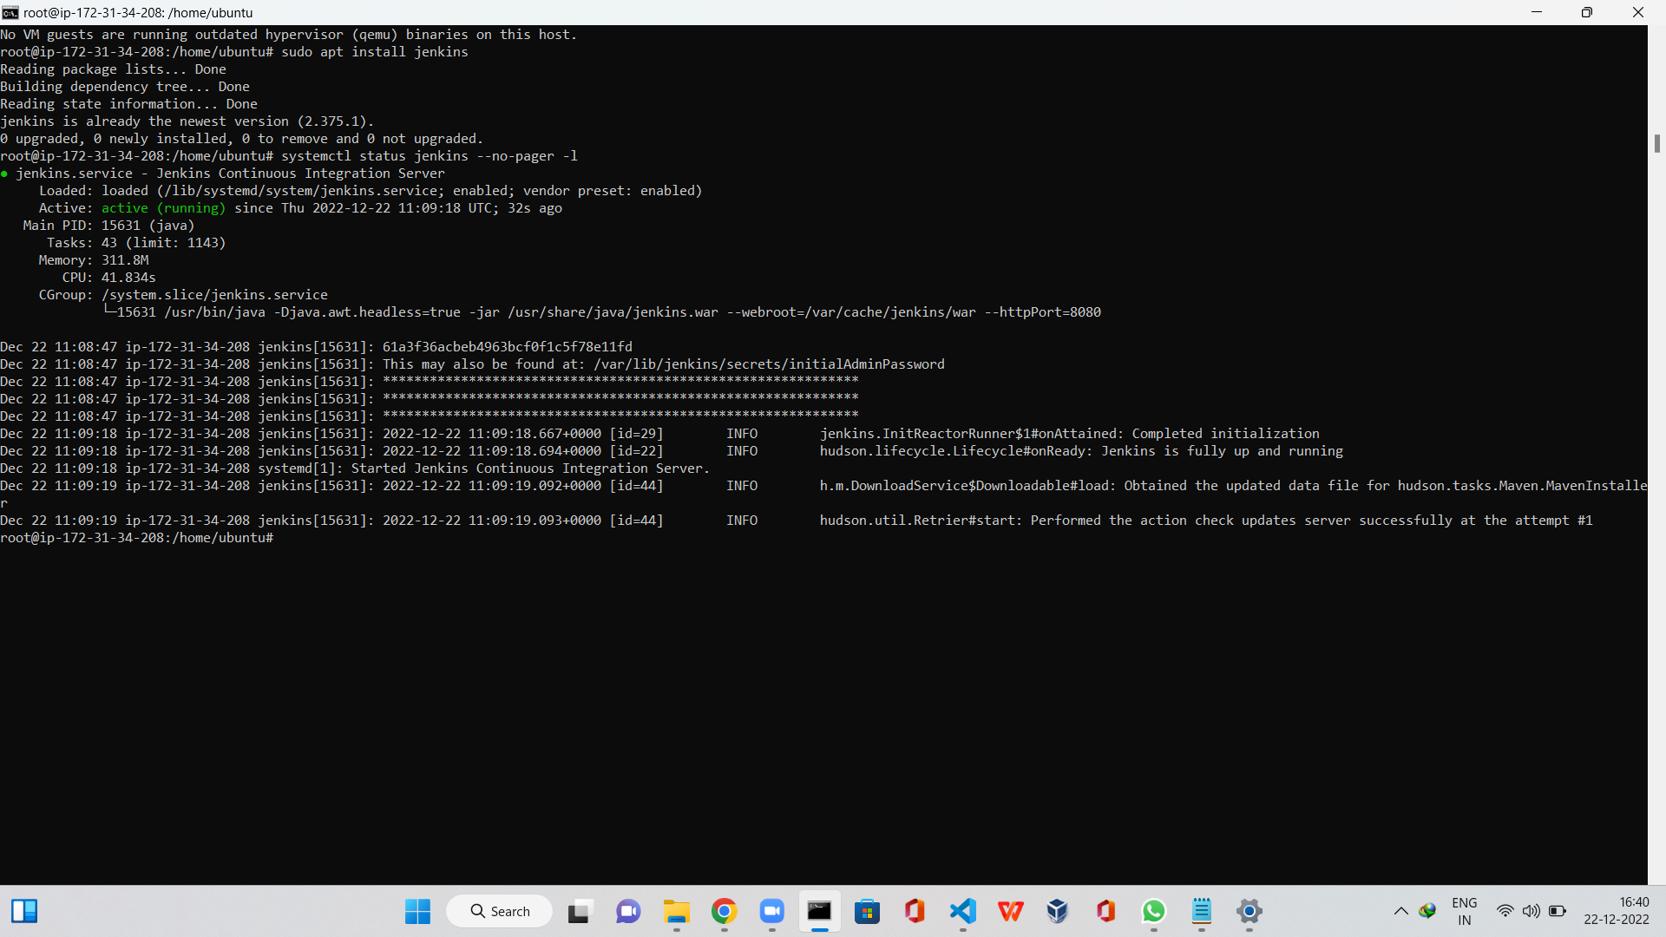

The login screen for accessing the jenkins server using <public ip>:8080 on browser.

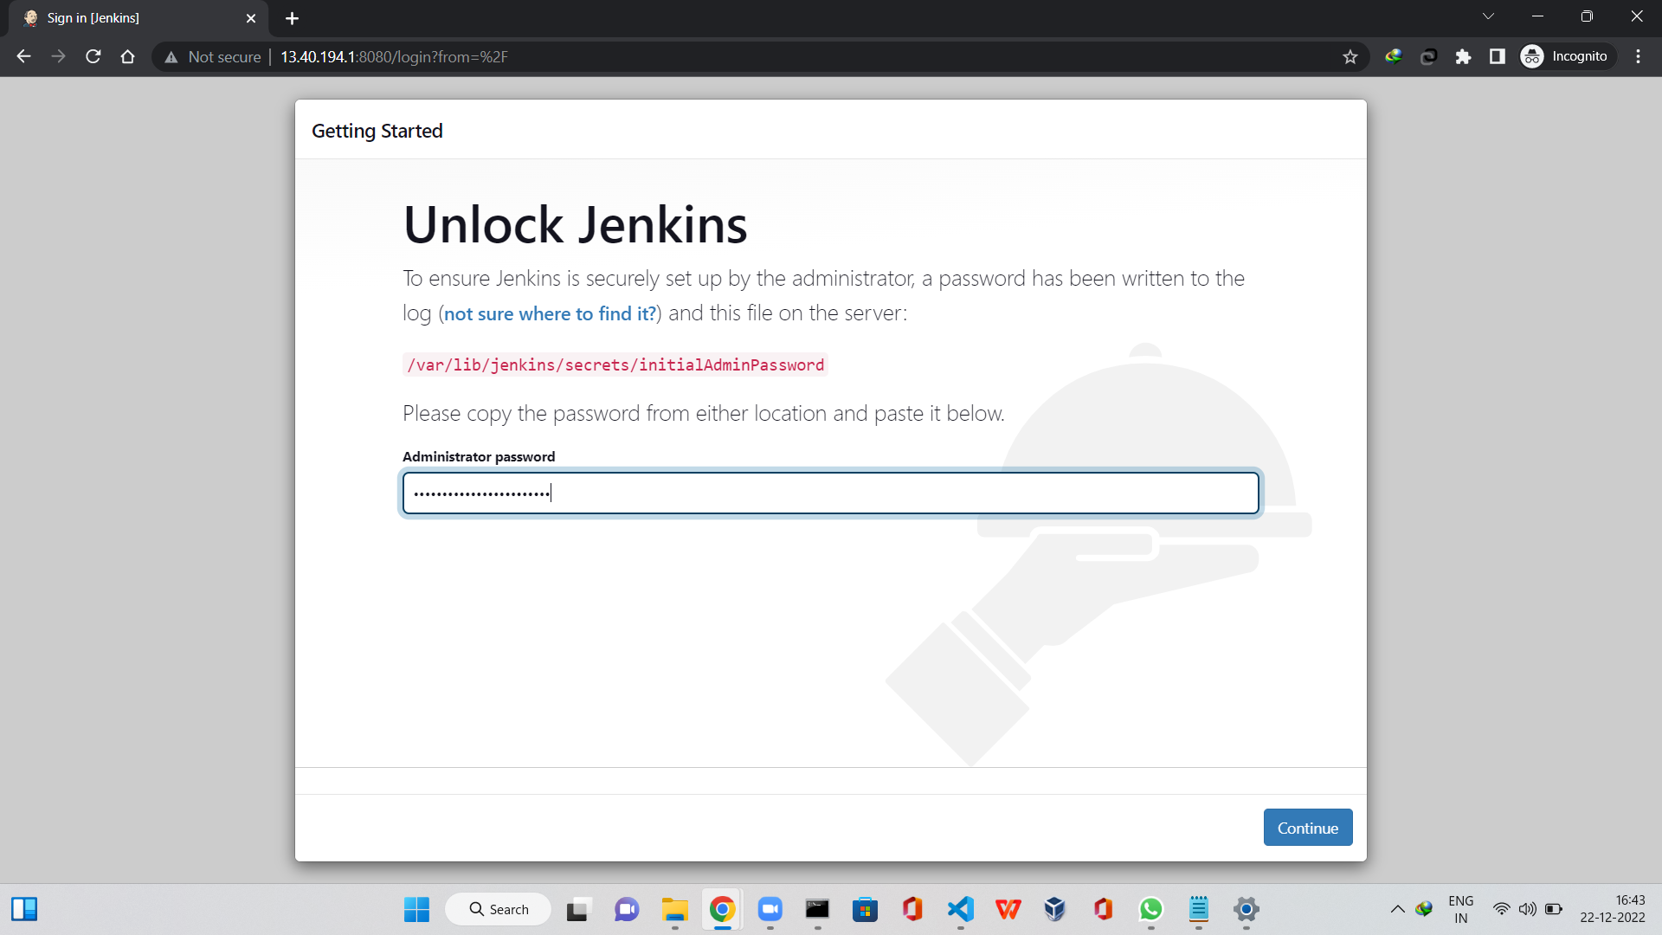

The initial plugins that are being installed before getting the dashboard console.

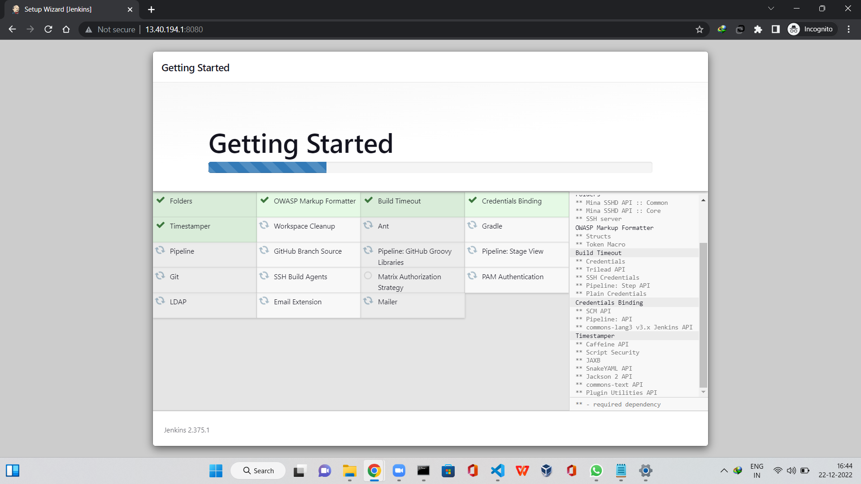

After creating the credentials the jenkins dashboard looks like this way with no jobs.

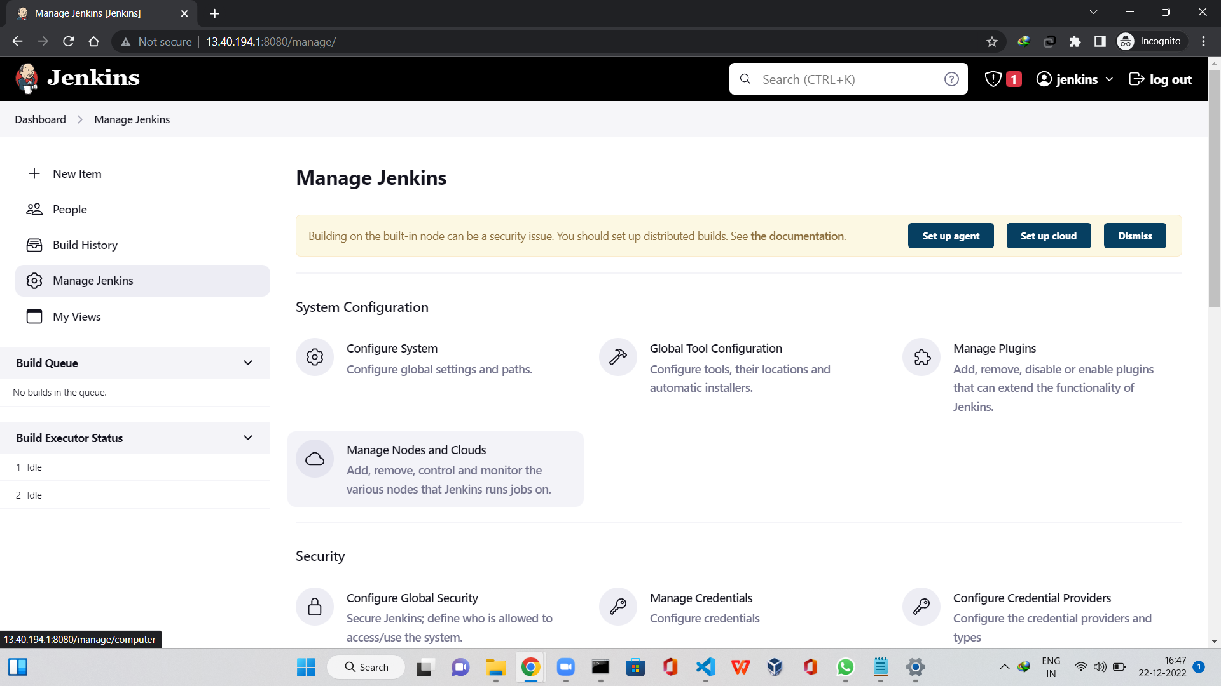

So, now we will create a new job in a freestyle project.

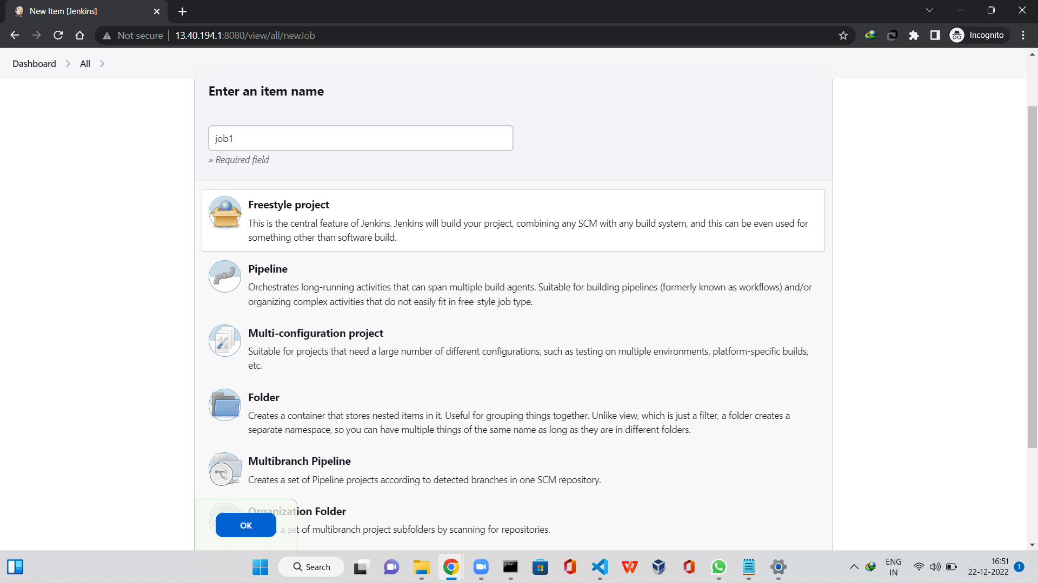

The webhooks are created down below with payload URL http://<public_ip_of_ec2_instance:port>/github-webhook/

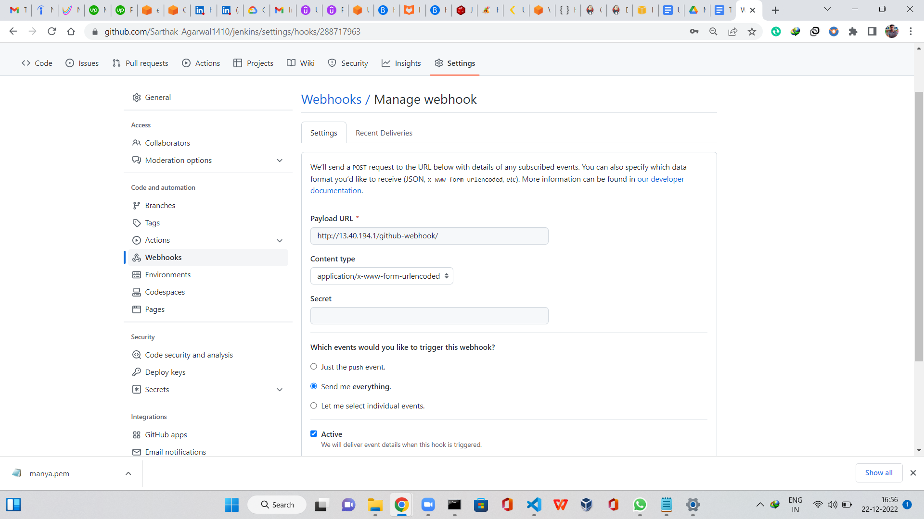

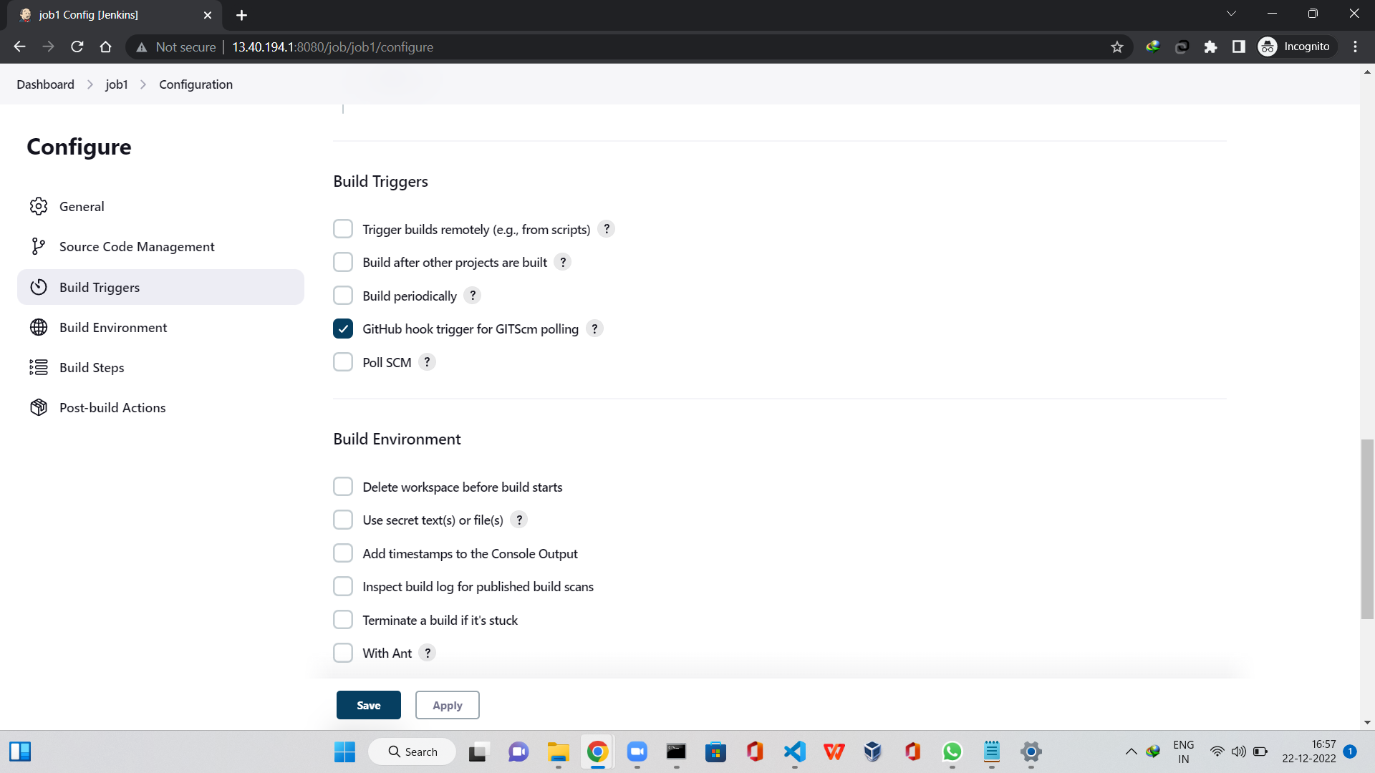

Console output for the very first time after running the job manually.

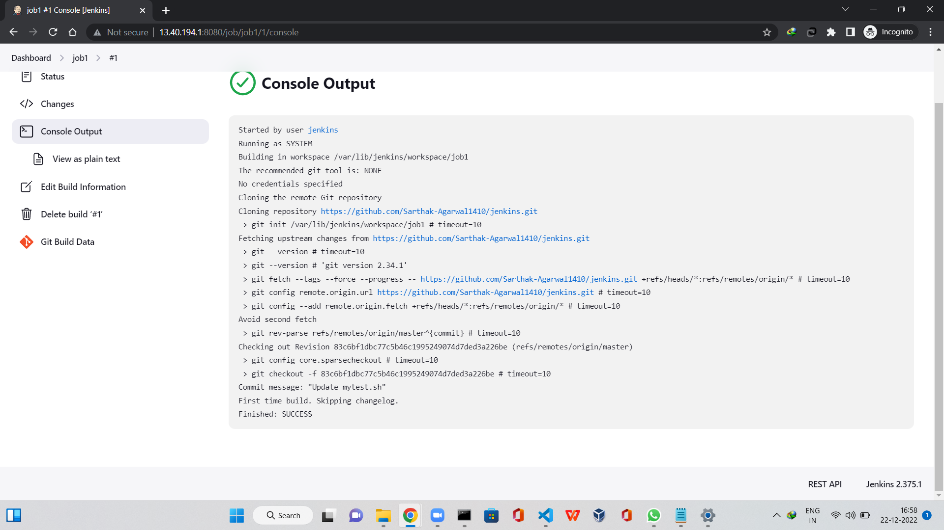

Now, Lets configure the slave agent and connect it with the master agent (built in node)

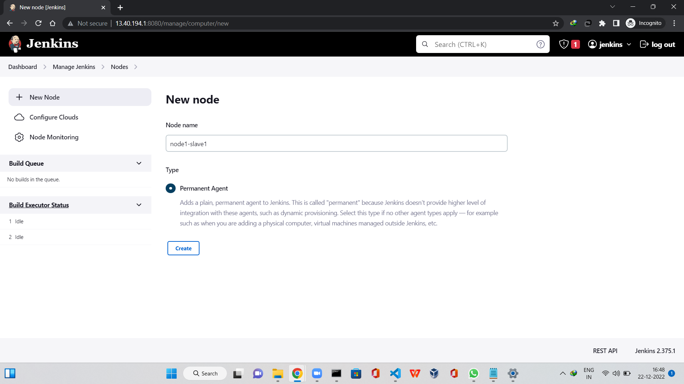

For the slave node we need another ubuntu instance which is shown below:

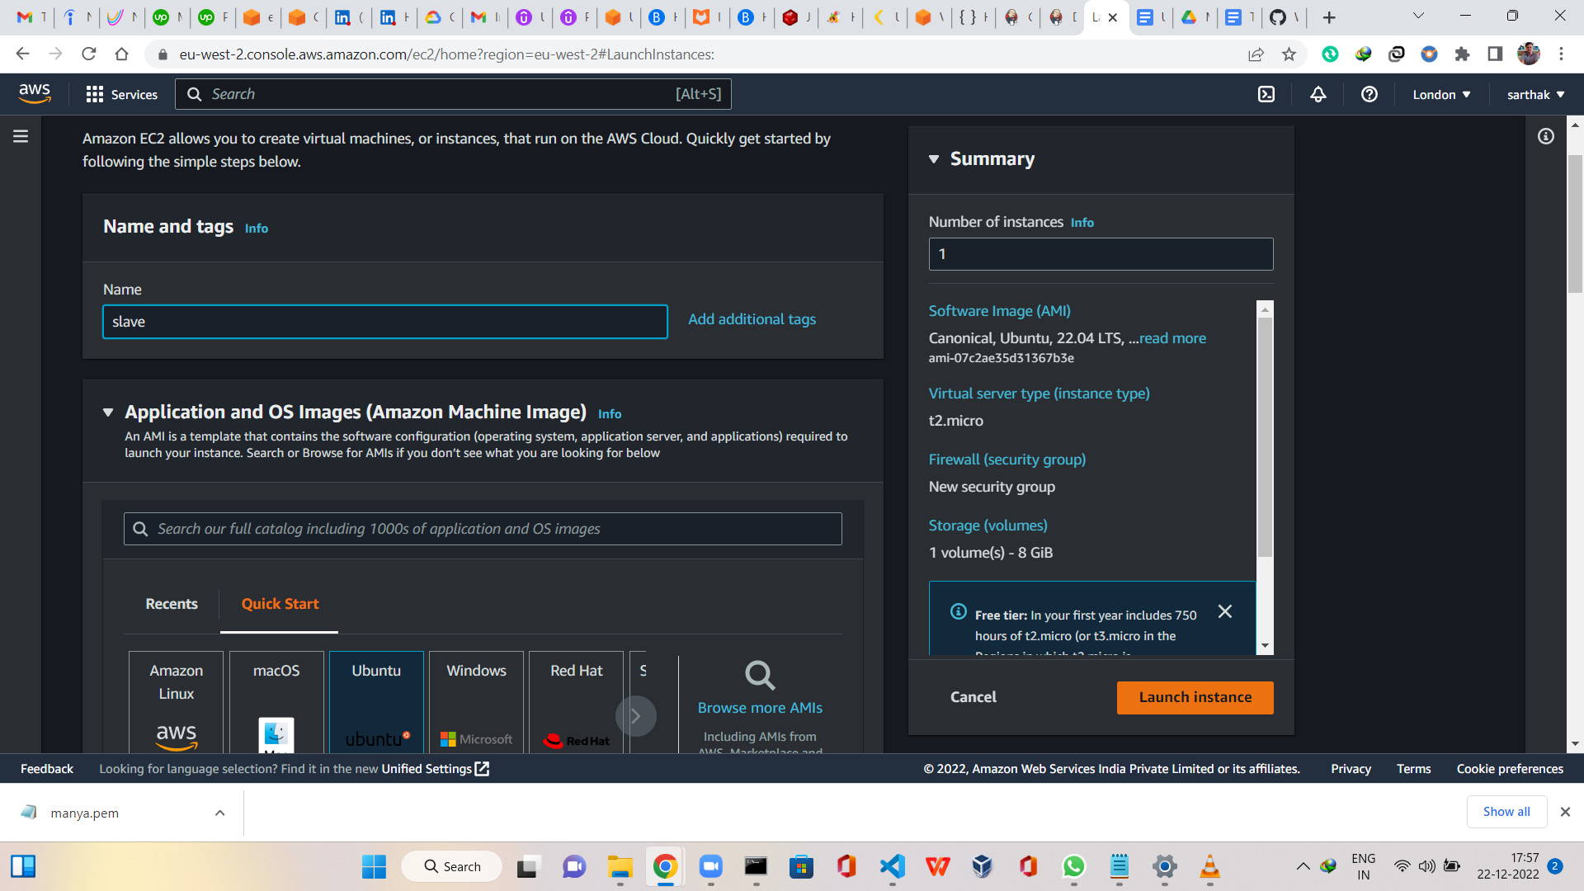

The instance summary for slave node is shown below.

Dont forget to copy the public IP which will be used as host in slave agent configuration

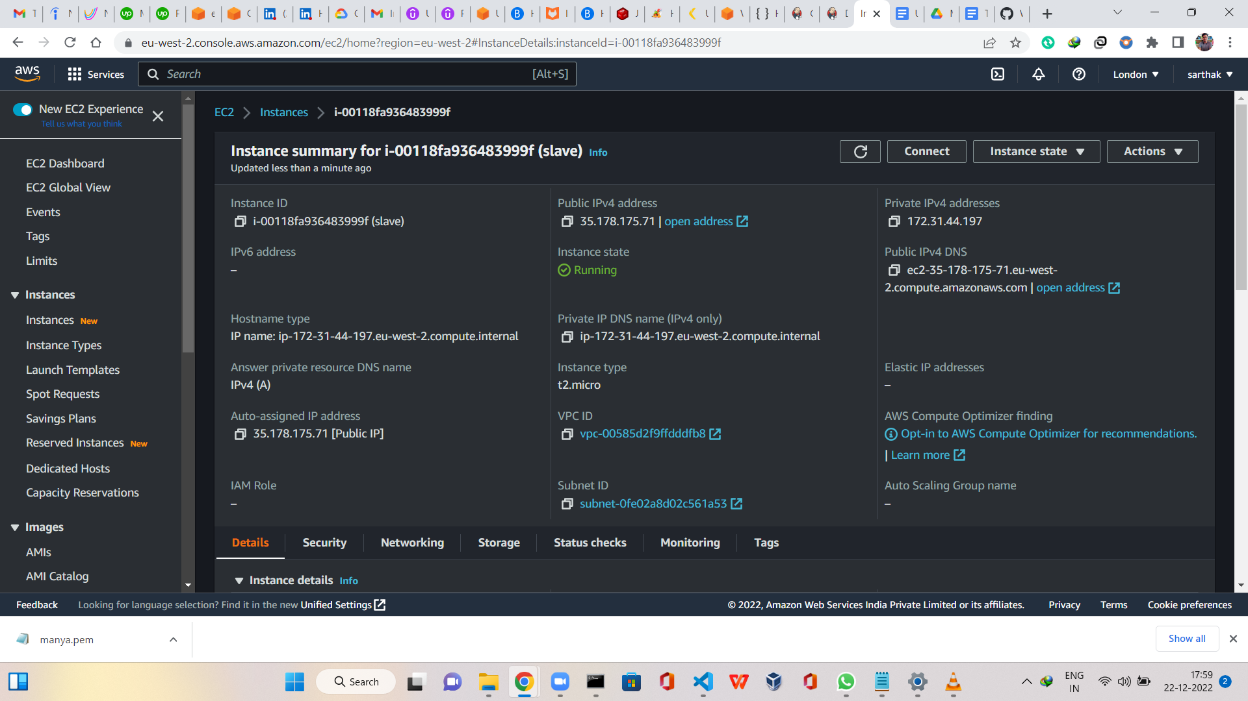

Lets attach this slave node to the master agent

Manage Jenkins >> Manage Nodes and Clouds >> New Node

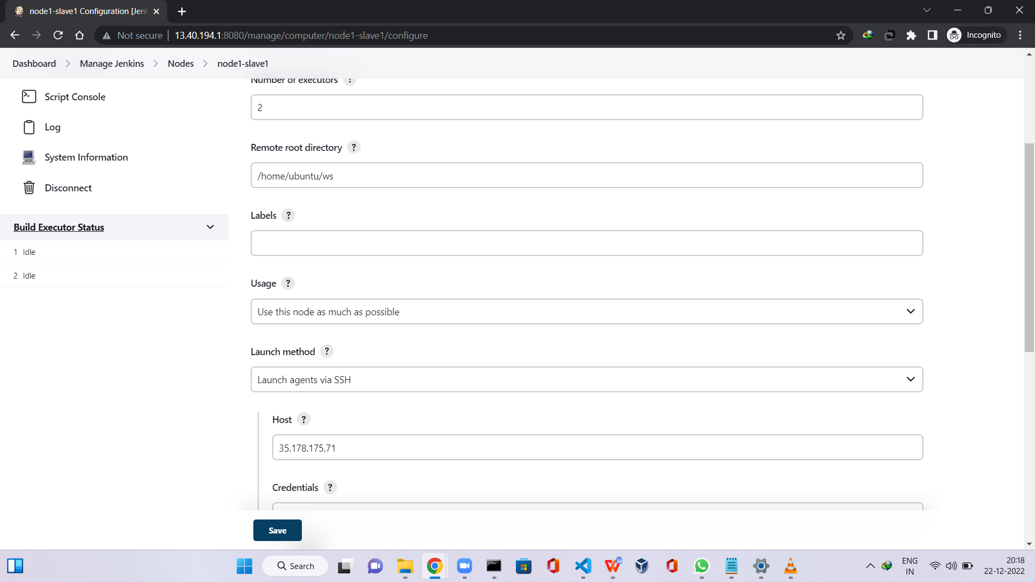

The username and key has to be given here for authentication.

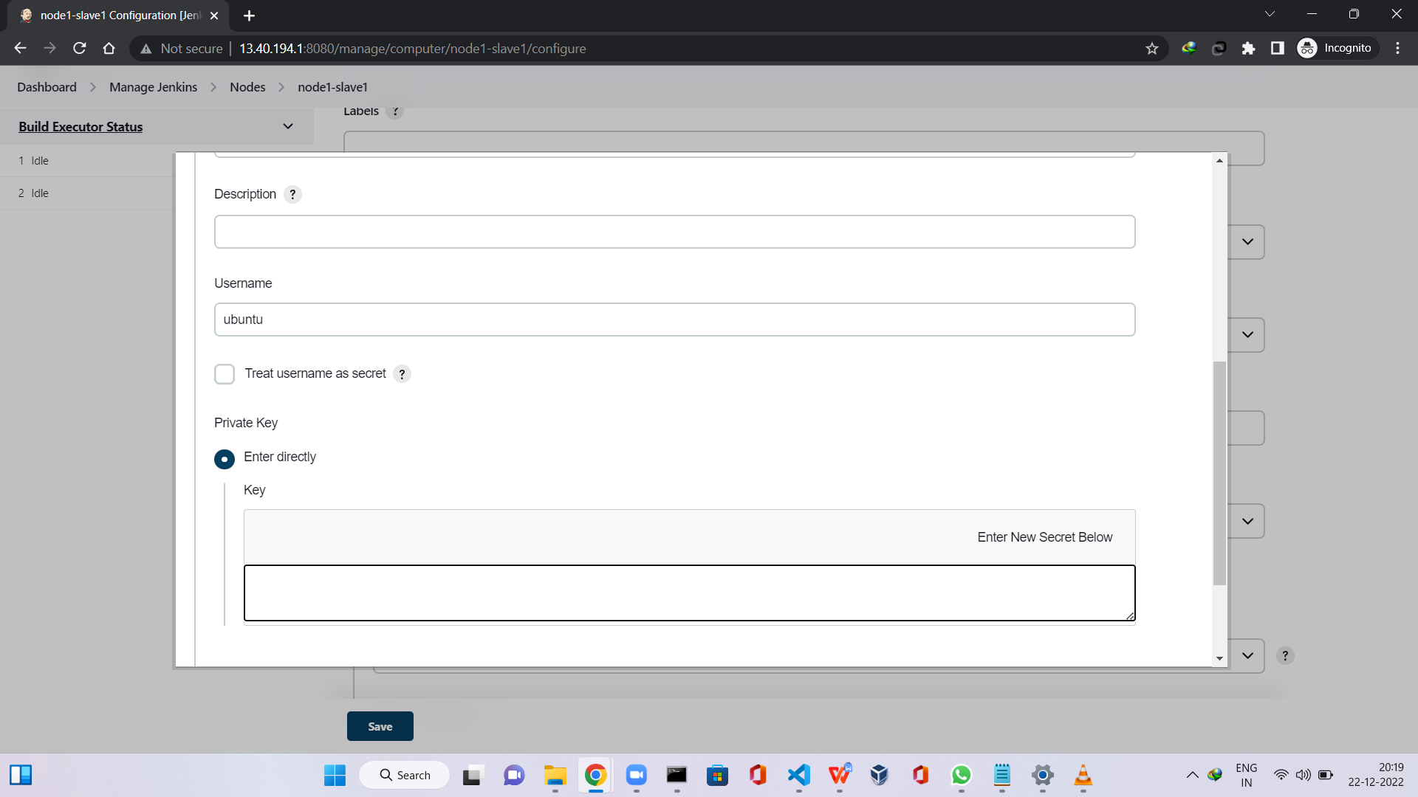

Authentication is successful between master and slave agent using SSH Protocol.

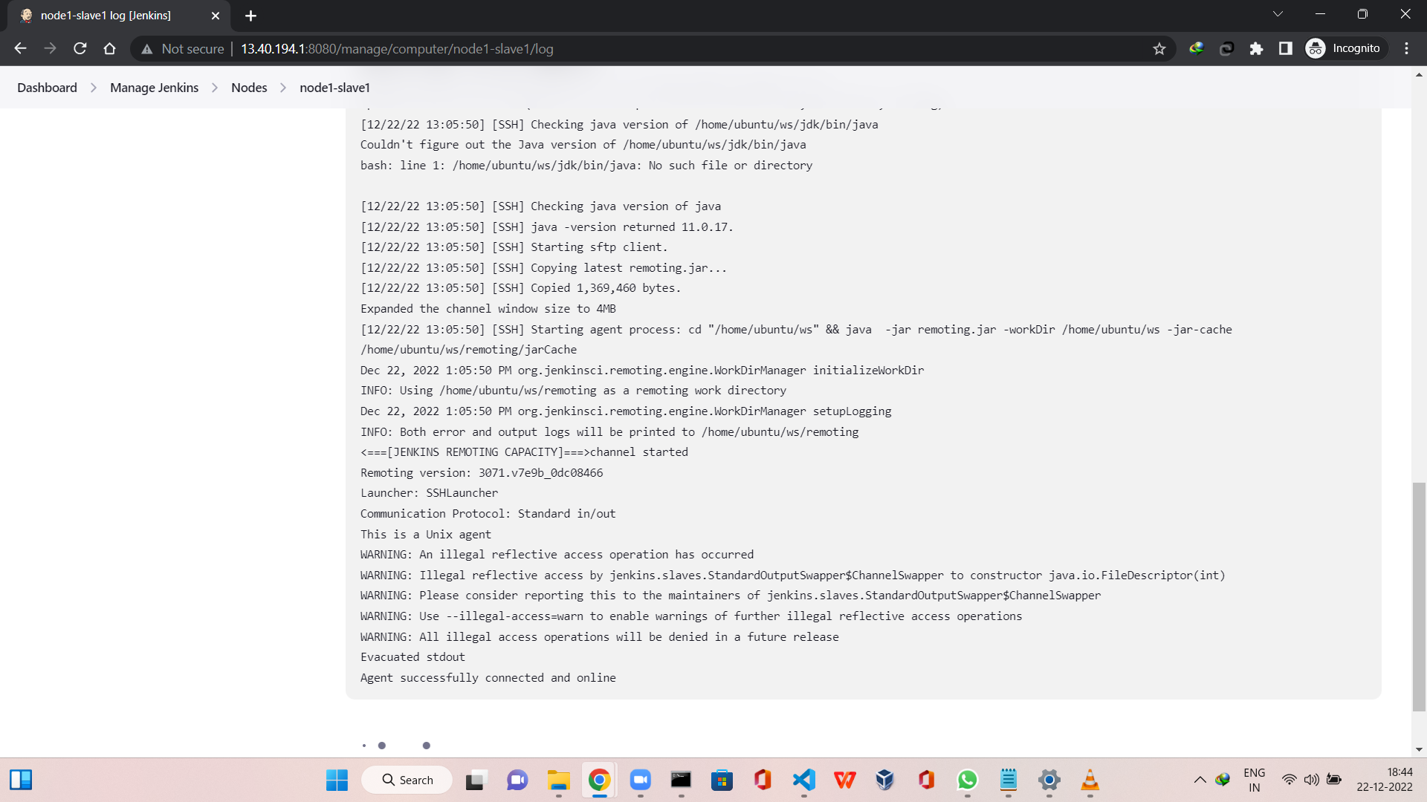

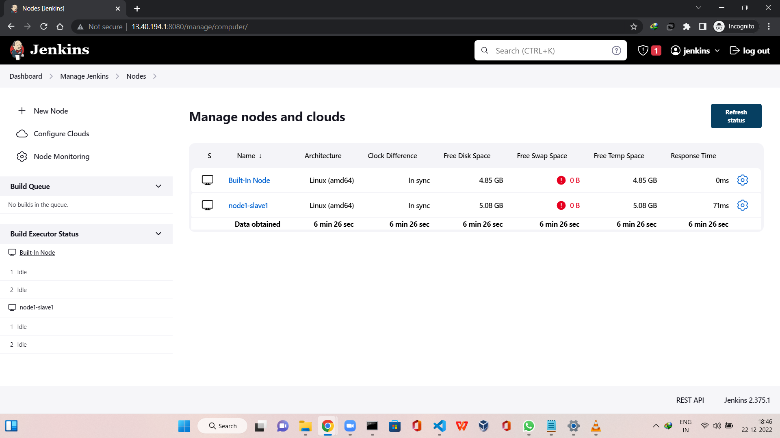

Lets install Chrome and Chrome Driver on slave agent using the script on Github.

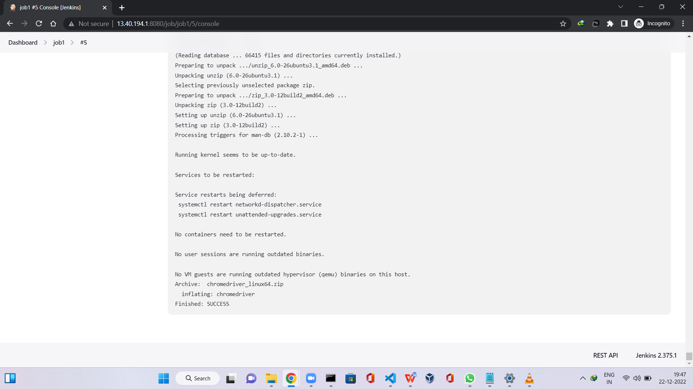

The job is running under the slave node section automatically which got success response above.

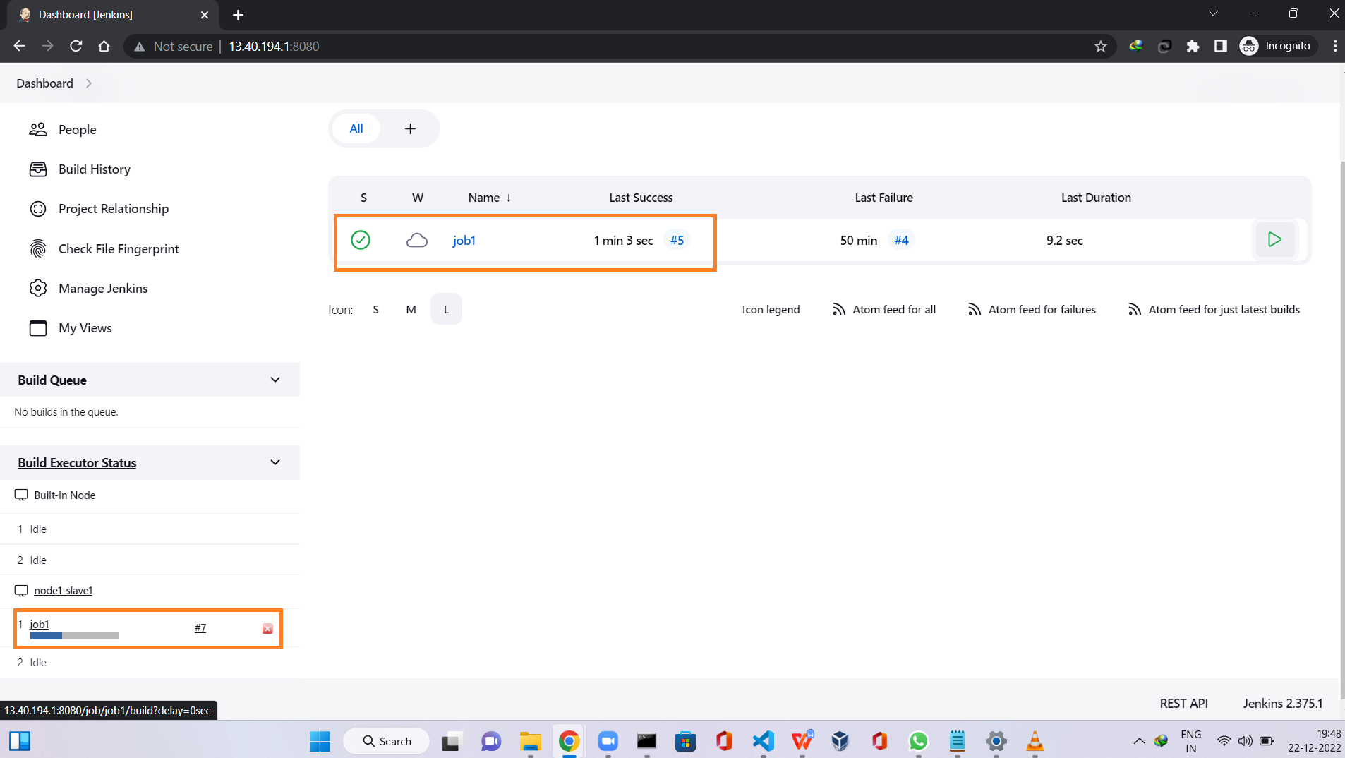

The GitHub code for installation of Chrome and chrome Driver is shown below.

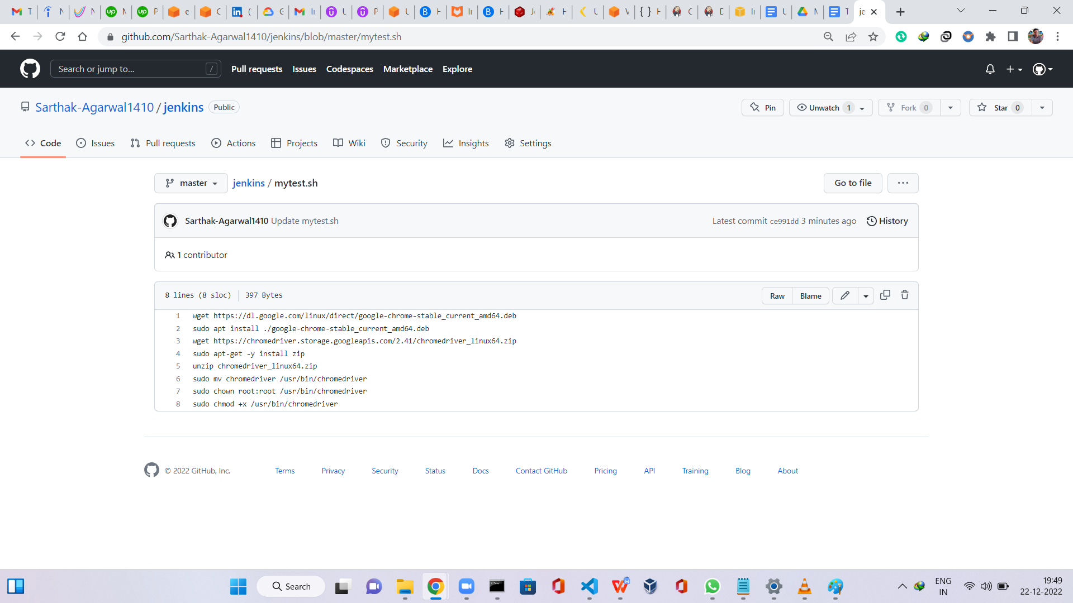

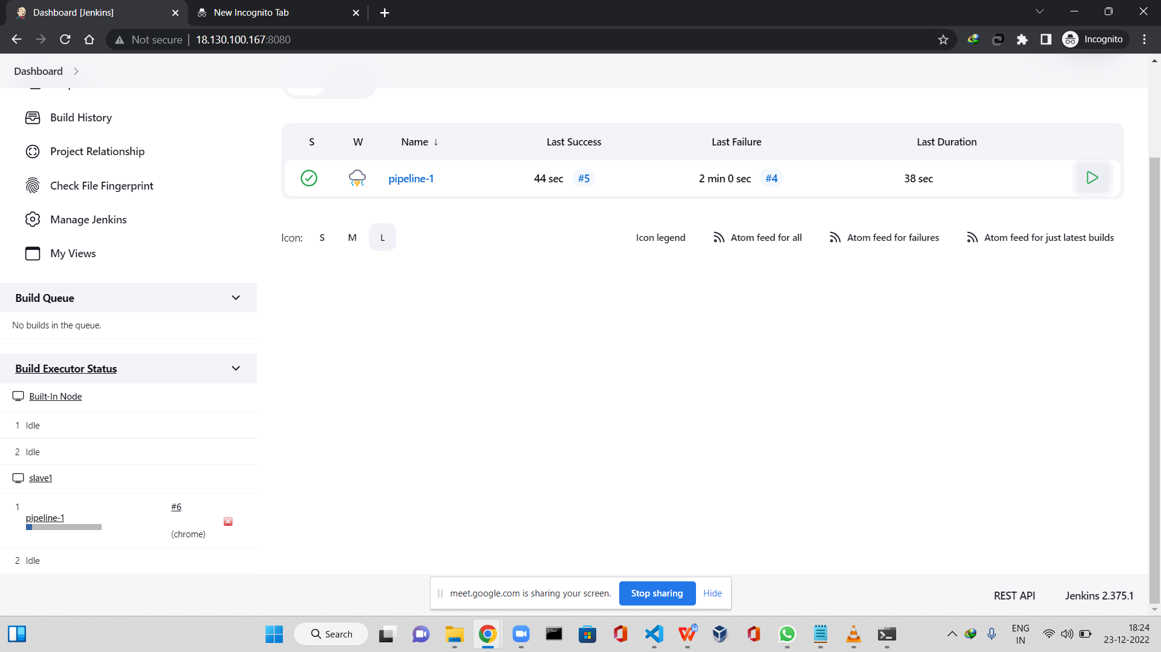

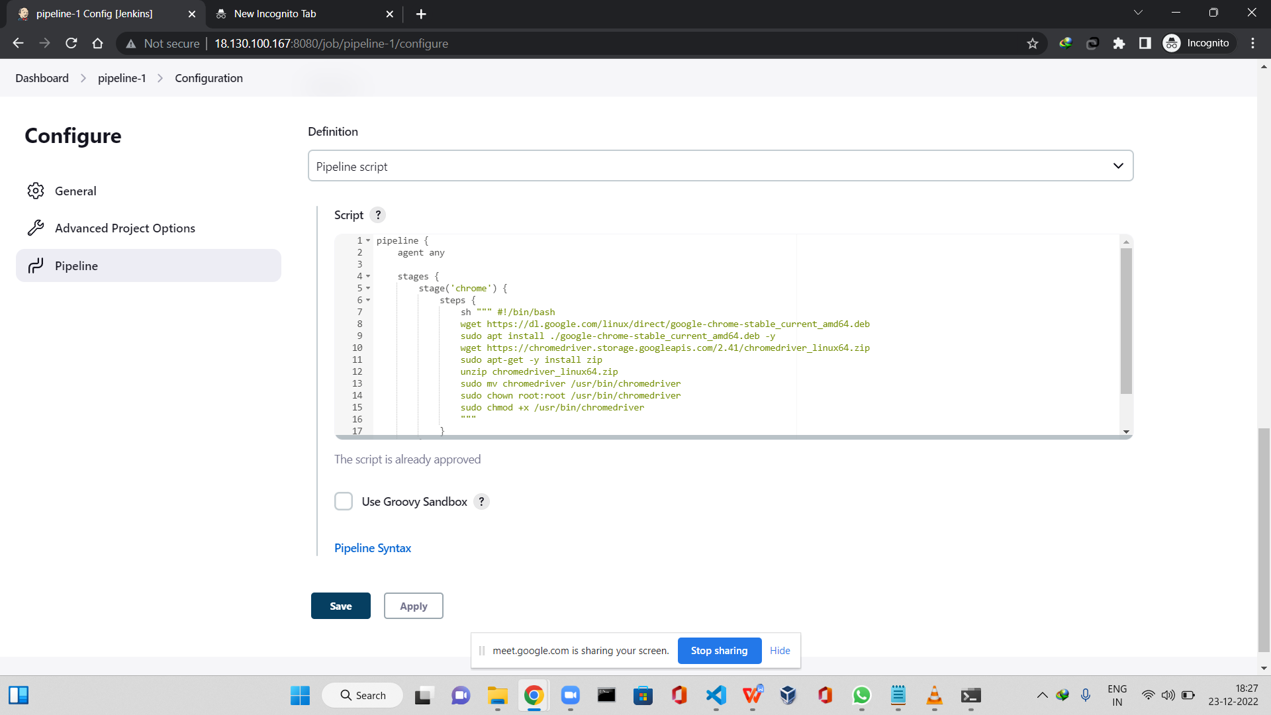

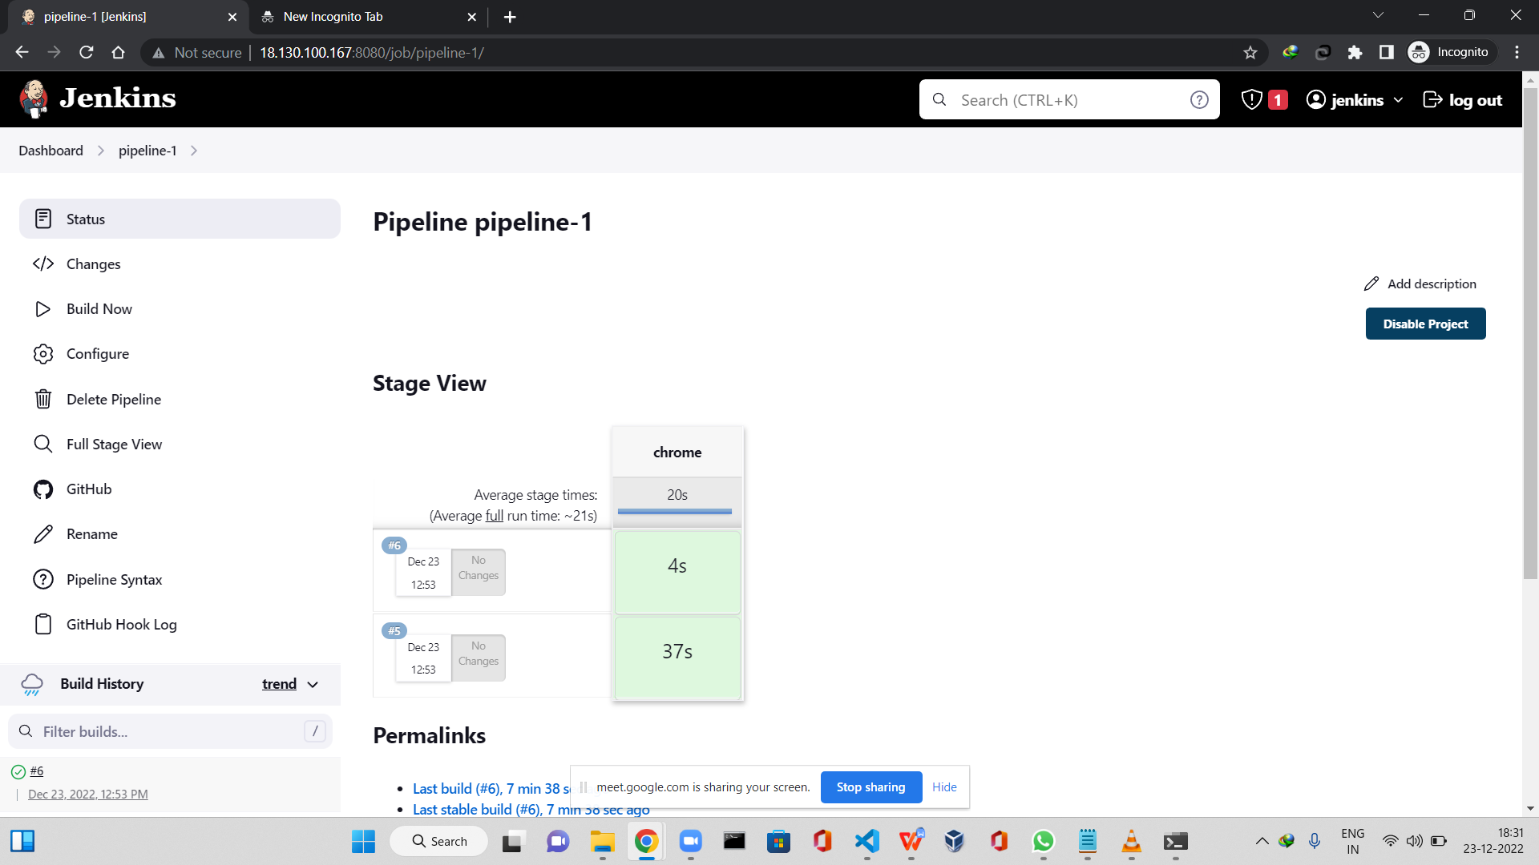

[GitHub Link for Code](https://github.com/Sarthak-Agarwal1410/jenkins/blob/master/mytest.sh)

Hope the procedure was explained in a good way by using various steps and shown screenshots for proper workflow of the task.

Thank You